SIGCHI Conference Proceedings Format
Cong Hua Chen  University of Toronto  catherinec.chen@mail.utoronto.ca | Melinda Chung  University of Toronto  melinda.chung@mail.utoronto.ca | Matthew Faenza  University of Toronto  matthew.faenza@mail.utoronto.  ca | Ryan Fung  University of Toronto  ryan.shuihongfung@mail.utoronto.ca | Sarah Gibeau University of Toronto  sarah.gibeau@mail.utoronto.  ca

INTRODUCTION

To fulfill the CHI’s topic of user groups untouched by technology, we decided to focus on cyclists and their safety. Through research we found that people who bike in trafficked areas do not have a safe way to navigate their routes without making constant stops to check their phones. In response to this problem we created Blinknav, a smartphone app that allows users to pre plan their routes and navigate safely without having their phones act as an interruption in traffic. The physical component of the app provides visual stimuli to the user’s sense of vision to indicate which direction to take. By focusing on the problem that are left unresolved by previous smartapps, this paper explores how cyclists are a new user group in the realm of safety.

Initial Problem space (Phase 1)
When brainstorming on the different problem spaces, we initially observed that people attributed with dyslexia had no outstanding devices to assist with their daily lives. We decided on creating a device that would support the learning experience of young grade school kids who had dyslexia. However, it did not take long before we realized that children with dyslexia was already was a problem group that is already oversaturated with solutions. Instead, we decided to re-examine the topic and we found that there weren’t many applications for those who were diagnosed with dyslexia as an adult. After some preliminary research, we had found that many dyslexics would have trouble reading on e-readers and websites. As a result, we entertained the idea of creating an application or an add-on for a browser to modify the displayed font to assist all dyslexics with reading on a daily basis. However there were still many other obstacles that we have failed to consider which eventually led to our decision to move away from dyslexia as a problem space. One reason that we decided against this problem space was that we are required to gain approval of the University of Toronto’s ethics board, which would have been very time-consuming as well as difficult given that to work with children, elderly and people with disabilities in general have the potential of posing major risk and liability for the university. In addition, given that this type of research is best conducted with close family or friends, and we only had one definite contact within this problem group, it would be incredibly difficult to obtain a great deal of information in this field given the time and resource constraints. Realizing how these problems would make our research and testing extremely difficult, our group decided to rethink what problem space to use.

Final Problem space (Phase 2)
With some guidance of our instructor, we were able to come up with the new problem space of urban cyclists who have trouble travelling in unfamiliar environments. We have noticed an extremely prominent gap in technology for cyclists, in the sense that they did not have access to any devices that did not threaten their safety whilst riding their bicycle. We researched different behaviours and experiences of cyclists in the city in order to find what kind of device would best cater to these problems. Many of the cyclists who currently use some sort of smartphone application that require them to glare at their phones frequently for updates, which distracts their attention from the road every time they do so, posing a danger to both themselves as well as others sharing the road. The results from the research done in “Visibility aids for pedestrians and cyclists” showed us that visibility aids, such as brightly colored reflectors and LED blinkers had contributed to safer cycling environments as more bikers and vehicles would be aware of the wearer’s presence. However, even we were noticed that any impairment to any of the human senses could prove dangerous for cyclists. If there were to be too much stimuli for a cyclist to see, one may become distracted from the immediate danger in their presence. As such, this remains to be a problem if the cyclist were to be distracted by any sounds that are irrelevant to their surroundings. For example, wearing headphones impedes the cyclist’s ability to listen to the traffic, such as vehicle horns, pedestrians walks and any communication in general. Through the research conducted in the study, “Fit of bicycle safety helmets and risk of head injuries in children”, we discovered most bicycles related accidents were due to ill-fitted if not lack of safety equipment. We decided that cyclists in new environments would be our problem space because most cyclists rarely used technology accompanied with their rides, and there were many unresolved safety issues presented through our research.

Research preparations
Before designing any prototype, our group compiled every member’s research on cyclists and found which problems were most common among the studies. The common problems would then become target subjects of further observation and inquisition. We found that creating a reasonable amount of stimuli for the human senses would create a more alert environment for those that are sharing the road. Another aspect of research we found in the journal, “Ubikequitous Computing” was that although there were many applications catered to promote cycling, none of the apps were created with keeping the user safe whilst cycling. The third and final point that caught our attention was that many injuries occurred because of ill-fitted safety gear. The purpose of our research was to gain background knowledge of cyclists and which of their problems which could be best solved using technology. We came to choose cyclists of all experience as the focus of our problem space, whether they had only rode for recreational purposes or rode bikes as main source of transportation. What we chose to fix was the well being of cyclists and to create a tool that enforces safety for the user to enhance their experience with cycling in heavily trafficked areas.

Target demographics
To further explore cyclists and their common problems, we created multiple research instruments used to gather data on the topic. Our first instrument includes a questionnaire which delves into any patterns between cyclists, their age, how comfortable riding in various environments and the types of safety equipment they wear. In our questionnaire we asked the testers if they had ever been in an accident or whether they were ever distracted by any overwhelming senses. As an experiment, our group decided to post our questionnaire onto reddit.com, in order to gather large amounts of anonymous data in a short amount of time. Specifically, we uploaded a Google questionnaire to subreddits that were dedicated to cycling in Toronto. Our reply size proved to be well received as we were provided with an overwhelmingly large volume of 193 responders to our questionnaire.

research Results (Summary)

Questionnaire (include table, data analysis)
The purpose of the questionnaires are to narrow down many problems that urban cyclists encounter on a day-to-day basis. Since these questionnaires were done anonymously, we will pose the identified problems during interviews to assess the credibility of the answers received.
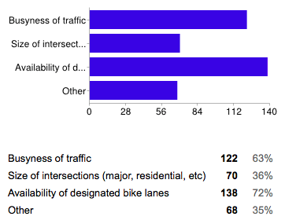
Figure 1. Data showing the choice(s) or feature(s) that cyclist consider during their trip.
Results from gathered from all participants illustrates that the busyness of traffic flow and the availability of bicycle lanes tremendously affects how they plan their trip.
Additionally, participants noted that they are aware of the consequences of using their phone while cycling but yet continue to do so because of the lack of a safer alternative. Interestingly, there was a significant amount of comments regarding the types of technology used while cycling on the road. Many responders, strongly aware of the dangers posed by these devices, strongly stressed that no earpiece or handheld device should be used while cycling. This opinion stems from the fact that both devices can cause a distraction, making cyclist more disconnected of their surroundings. Participants who only use their phone while pulled over found it a hassle to keep stopping amidst travelling to check a map.

Interviews
Within our interviews, we asked the interviewers to describe circumstances when they felt unsafe whilst riding their bike. Many responders replied by stating that they become stressed when larger vehicles occupy the road, as many motorists often disregard the presence and safety concerns of cyclists sharing their lanes. A few responders also shared personal stories of dangerous encounters, naming motorists’ ignorance as the root cause of serious accidents. Another ongoing concern is that pedestrians are a common obstacle to avoid, as many would often jaywalk and cross against traffic lights, putting themselves and others in danger.

Observations
Our third and final instrument was non-interactive observation, where we had simply waited the intersection of St. George and College Street to observe the habits of cyclists. The time spent observing the subjects lasted approximately two hours during the afternoon rush hour of 4:00 PM to 6:00 PM. In the time we spent observing anonymous subjects, we noticed that most riders wore light reflection gear and helmets as a safety precaution. In rare cases some riders even had cameras strapped on their helmets, possibly to assume some form of evidence in the case of an accident.

Stakeholders and Scenario
Using the evidence found through the instruments, we were able to create scenarios to depict the common cyclist and their needs. Our stakeholders included motorists, pedestrians and of course, our main focus, cyclists. Motorists with limited awareness generally provide a great danger to cyclists, as they often collide with others or drive too close to bike lanes. Many responders have expressed discontentment with motorists pulling over on bike lanes, finding both disrespectful of cyclists, not to mention capable of posing a serious risk to cyclists that are travelling closely behind their vehicle. Pedestrians with disregard to traffic laws pose a danger to a similar degree. Some scenarios created by our group depicted the common bicyclist through a nervous cyclist named, Cautious Kate, where most of the scenarios include her getting into accidents that were caused by both her own experience on the road, as well as the negligence of others in traffic. We also created a persona named Rebellious Robert to illustrate how the ignorance of cyclists themselves can pose danger on the road.

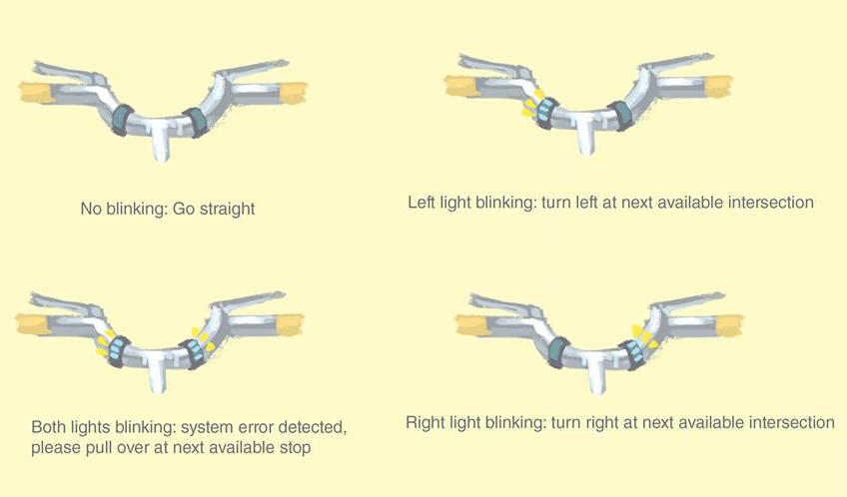
Figure 2: Sample of a wide figure. Be sure to place at the top of the page or bottom of the page.

Devising a prototype
Given the results from the research conducted, we noticed in situations where cyclists are not familiar with their surrounding, they often resort to using mobile navigational apps while cycling, which poses a clear safety risk. Not only would the cyclists cause themselves harm, they are also a hazard to incoming traffic and pedestrians. Additionally, users complain of being unaware of unexpected route closures, rough road terrains and weather.
As a result, utilizing the mapping technology available, we devised a prototype, Blink Nav, that would allow users to set their destination and generate routes using their preferences by factors that are especially important for cyclists, such as road type/condition, terrain, and traffic. To reduce their need of interacting with a visual interface and improve their safety on the road, this app will wirelessly synchronize navigational signals via GPS technology and display the signals using Bluetooth to an external lighting device mounted on the handlebars of the bike. The purposes of these lights are to notify the cyclist in real time, when to turn left or right on the road. As the signals are highly visible in the cyclists’ peripheral vision,, users now do not need to read from the actual map on their mobile device.

priliminary testings
To begin, it’s important to note that during the period of testing, we conducted a light prototype test. This means no cyclists or users in general were mounted on a bike on an actual road. Instead, we chose to do a usability test with our participants by assigning them a task to perform on the Blink Nav application. The goal of this preliminary test is to observe users and conduct interviews to understand what aspects were good and could be further improved,
While performing our first phases of tests with our classmates; some of which who are actual cyclists, participants expressed how design aspects such as how the transitional arrows, location of buttons in certain places and difficult terms may confuse new users or people not fluent with the using apps in general. Some of the significant changes that these participants proposed are:

1) The large settings button on every single page is misleading and it is best to only have it on the main screen.
2) Remove the main menu and use the first map screen as the start-up screen
3) Use icons instead of explicitly wording weather, road conditions, etc.
4) After searching for the desired route, the resulted route of travel should be illustrated on an actual map, allowing users to visualize the actual route before selection
On the other hand, all users were able to perform the task analysis properly, demonstrating that the design was intuitive and straightforward. Notably, participants realized that using a phone while cycling can be a hassle and this prototype offers a fresh new alternative.
As a result, we are utilizing these feedbacks in moving forward with our implementation.

FINAL Prototype
We took the suggestions made by users from our early tests and begin to make modifications to suit their needs. Currently in the main menu, the application first prompts the user for their current location and destination. In both search bars, when certain characters are inputted the latest searches will be displayed. Once users are satisfied with their input, they will transition to the rank screen. In this screen, we significantly cleaned up the design. Users noted that there was just too much text in the previous versions and universally understood icons would be a better option. As a quick note, in this version, the traffics lights, bicycle and road respectively represents the traffic flow, bike lanes and paved roads. Furthermore, for each routes listed, once clicked, a window would popup, enabling users to visually see where this route leads. When users are ready to begin their trip, the next screen will automatically attempt to the LEDs then transition to the live navigational system. Here, users can click on the weather and traffic icon to observe the current weather, road conditions and travel recommendations.

Conclusion

ACKNOWLEDGMENTS
We thank all the volunteer participants as well as our instructors in providing constructive feedback, allowing us to design Blink Nav.

REFERENCES
- Kwan, I., & Mapstone, J. (2004). Visibility aids for pedestrians and cyclists: a systematic review of randomised controlled trials. Accident Analysis & Prevention, 36(3), 305-312.
- Rivara, F. P., Astley, S. J., Clarren, S. K., Thompson, D. C., & Thompson, R. S. (1999). Fit of bicycle safety helmets and risk of head injuries in children. Injury Prevention, 5(3), 194-197.
- Rowland, D., Flintham, M., Oppermann, L., Marshall, J., Chamberlain, A., Koleva, B., ... & Perez, C. (2009, September). Ubikequitous computing: designing interactive experiences for cyclists. In Proceedings of the 11th International Conference on Human-Computer Interaction with Mobile Devices and Services (p. 21). ACM.

The columns on the last page should be of approximately equal length.
Remove these two lines from your final version.

